University of New Orleans

Department of Computer Science

**FALL 2019: CSCI 6522**

**Programming Assignment # 2**

Machine Learning - II

Submitted to:

**Professor Dr. Tamjidul Hoque**

By

Name: **Astha Sharma**

Student ID: **2564173**

From the given dataset, we know the following:

Number of input nodes = 4 (because of the 4 features in the dataset)

Number of output nodes = 3 (because there are 3 sets of output class)

Optimal number of hidden layers = 1 (performs better). Performance decreases as the hidden layer increases.

Optimal number for neurons in a layer = values in between the number of input and output nodes (average can also be taken)

Therefore, the value of neurons for the hidden layers in each Neural Network is taken as either 4 or 3.

RESULT Obtained from different ANNs are as given below:

1. **ANN1 [4 4 3]**

**Average Error Plot:**

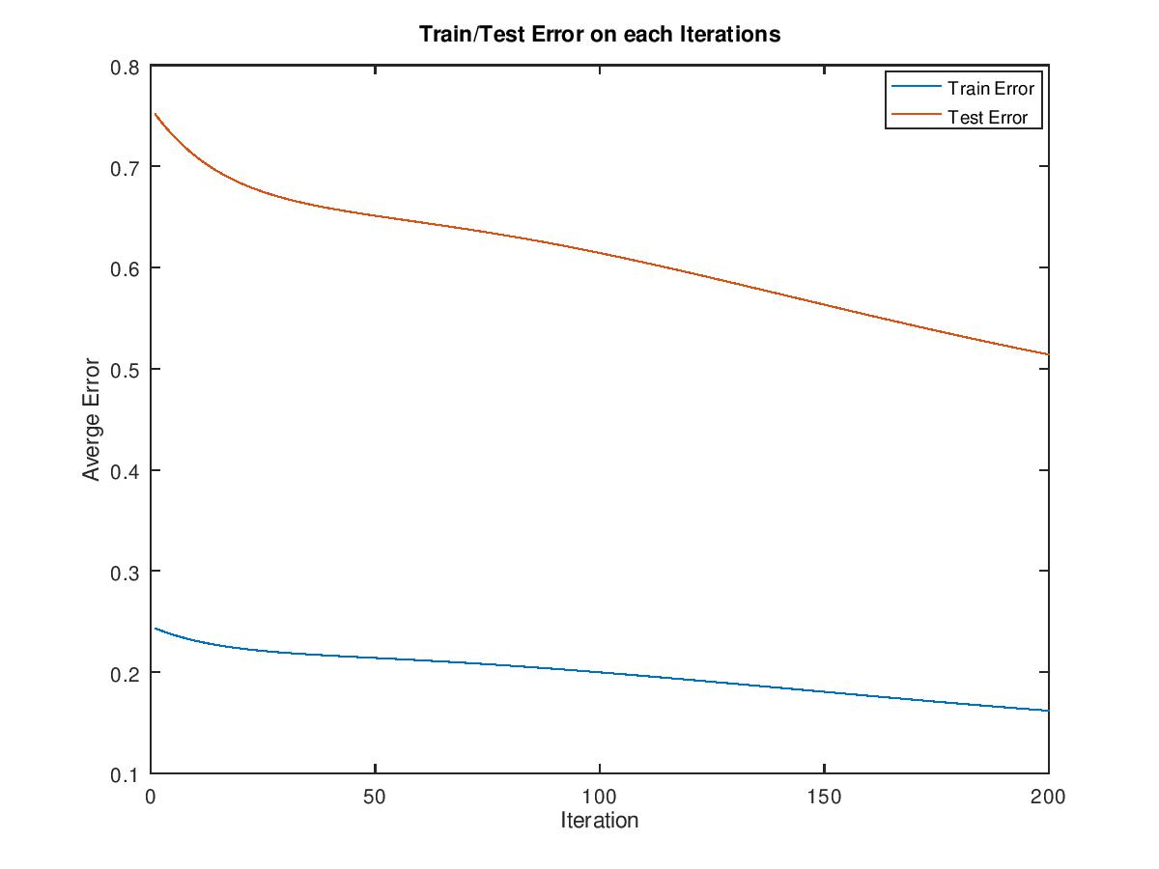

**Average Accuracy Plot:**

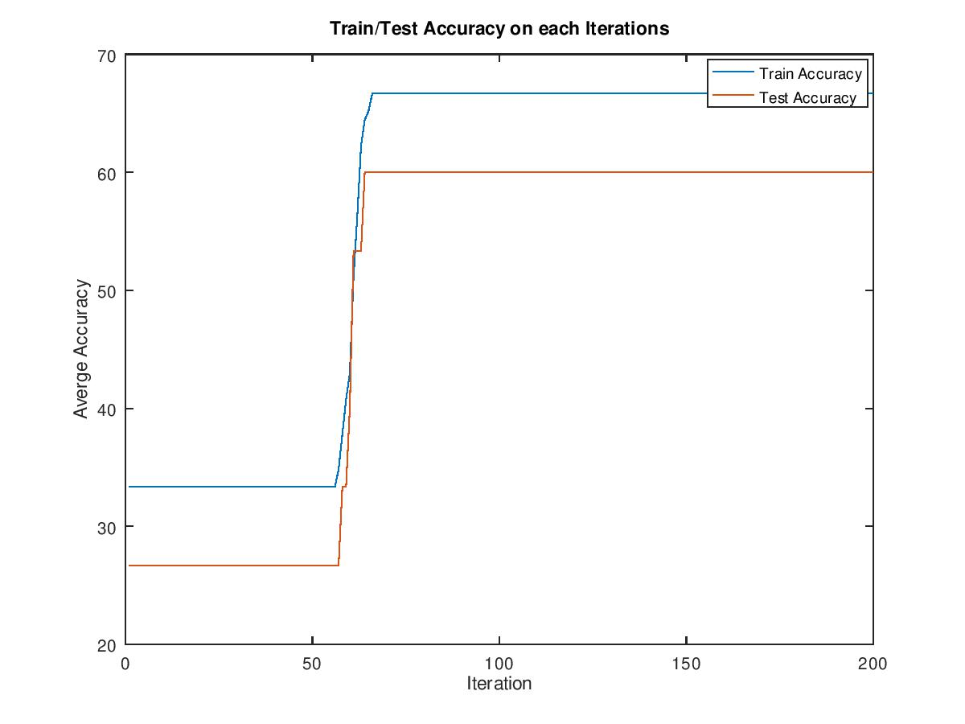

1. **ANN3 [4,4,4,3,3]**

**Average Error Plot:**

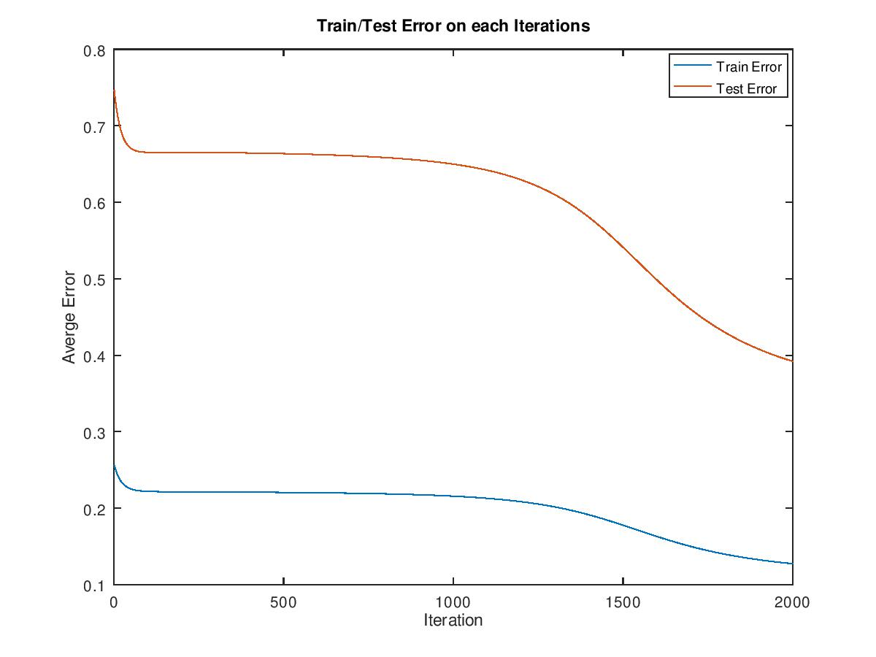

**Average Accuracy Plot:**

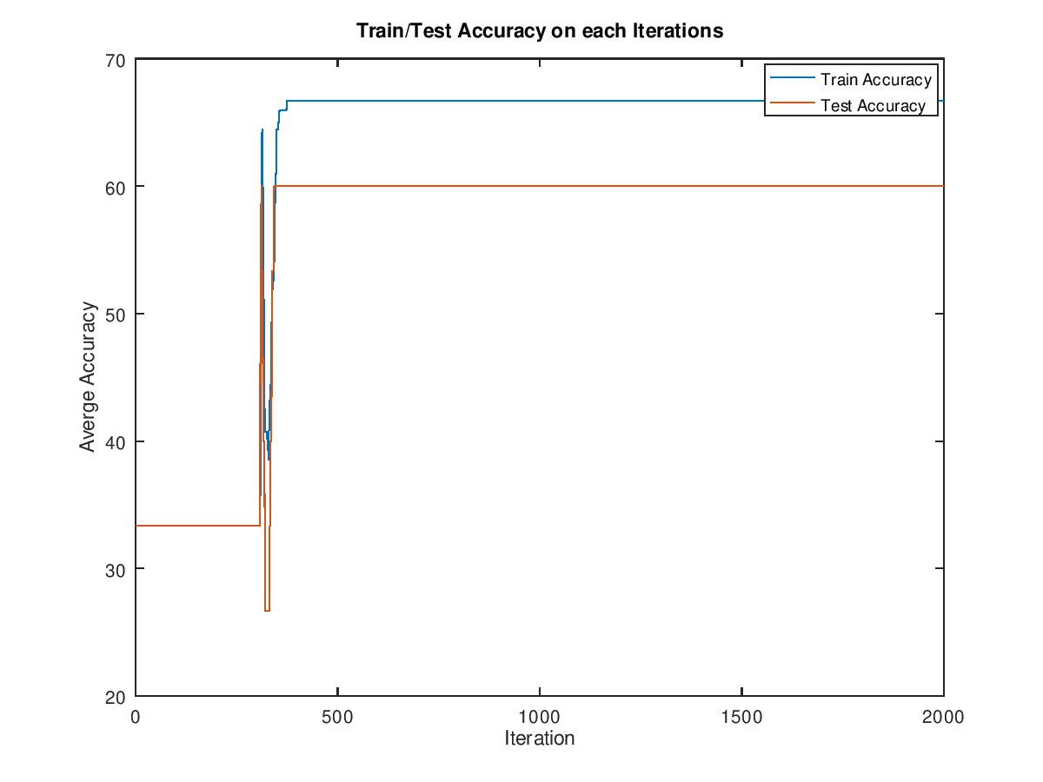

1. **ANN7 [4,4,4,4,4,4,3,3,3]**

**Average Error Plot:**

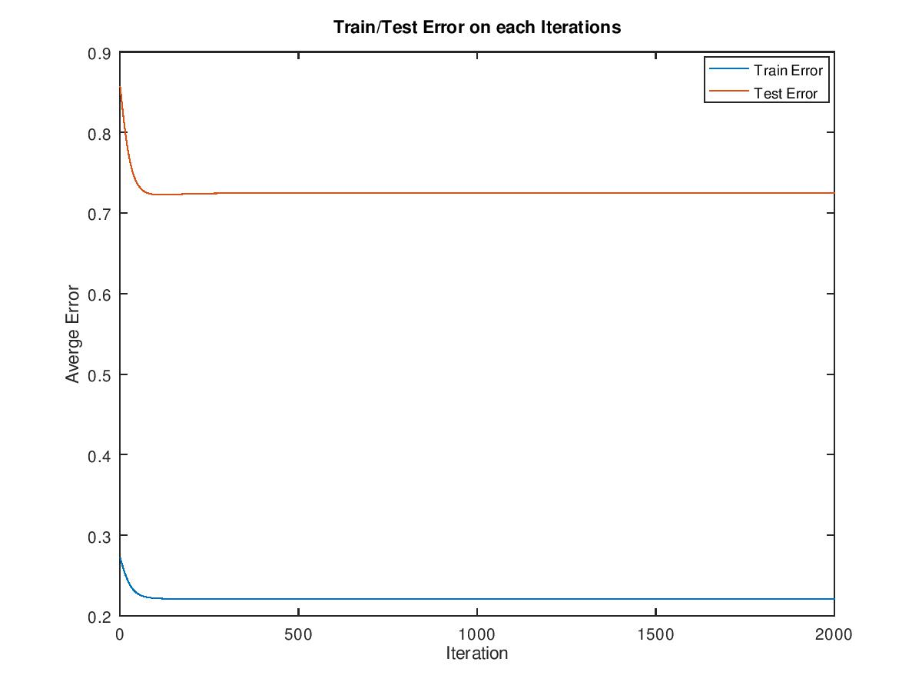

**Average Accuracy Plot:**

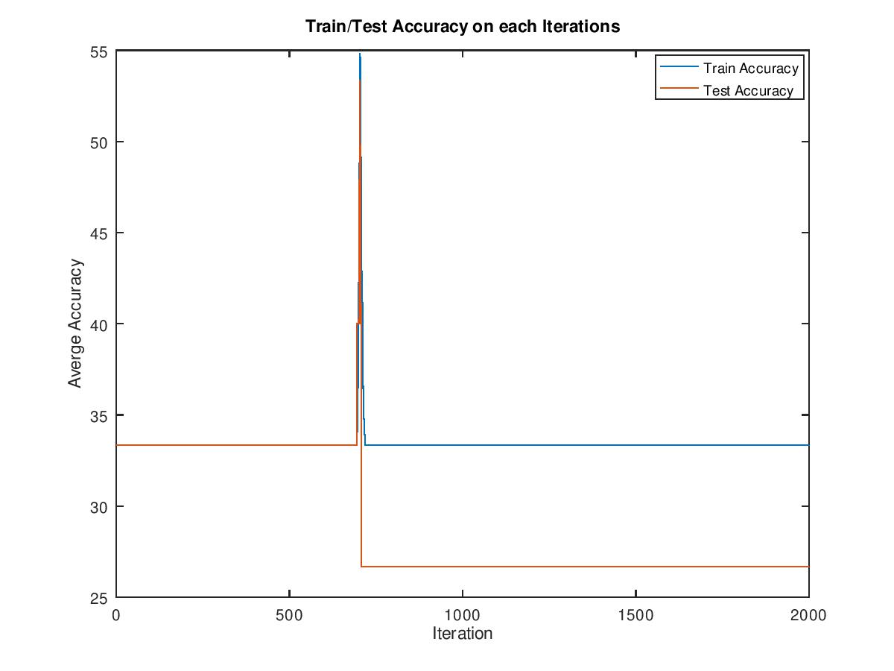

1. **ANN3 + Momentum**

**Average Error Plot:**

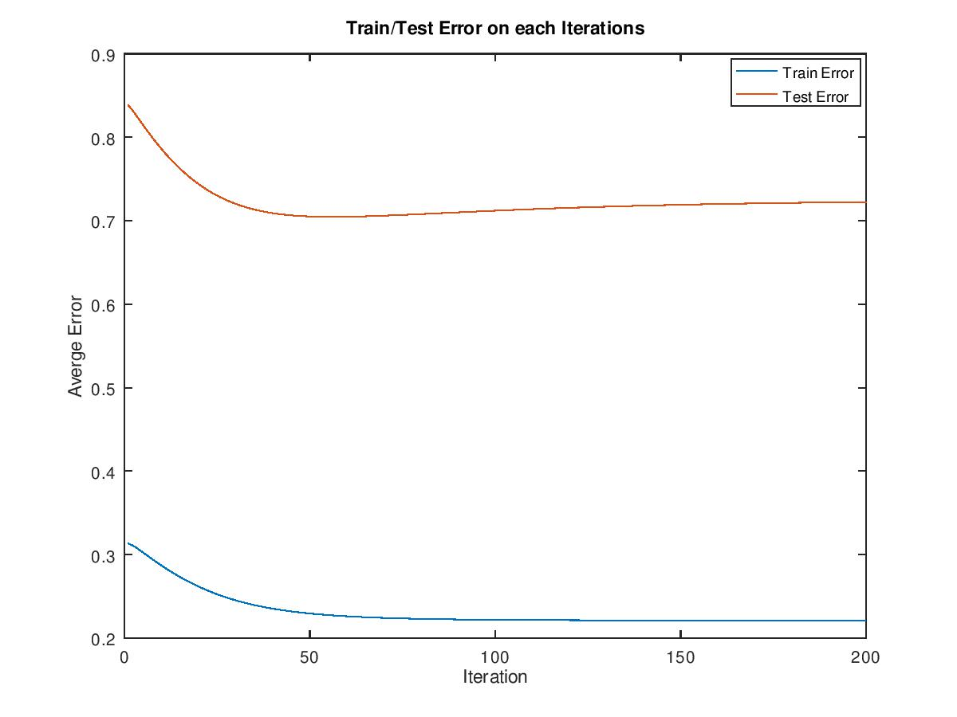

**Average Accuracy Plot:**

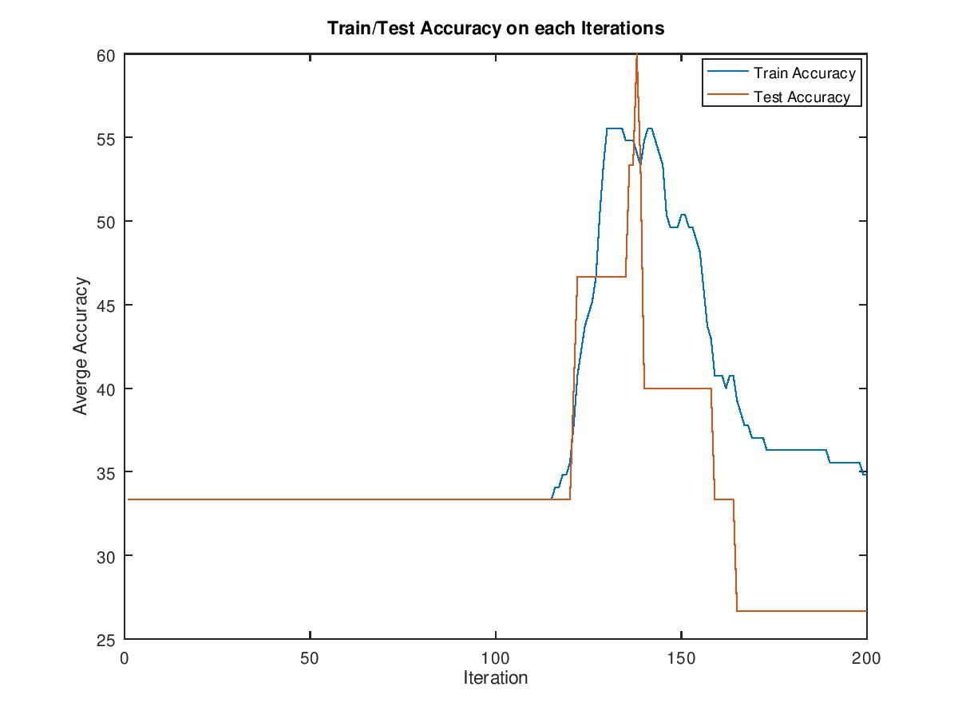

1. **ANN3 + GA**

**Average Error Plot:**

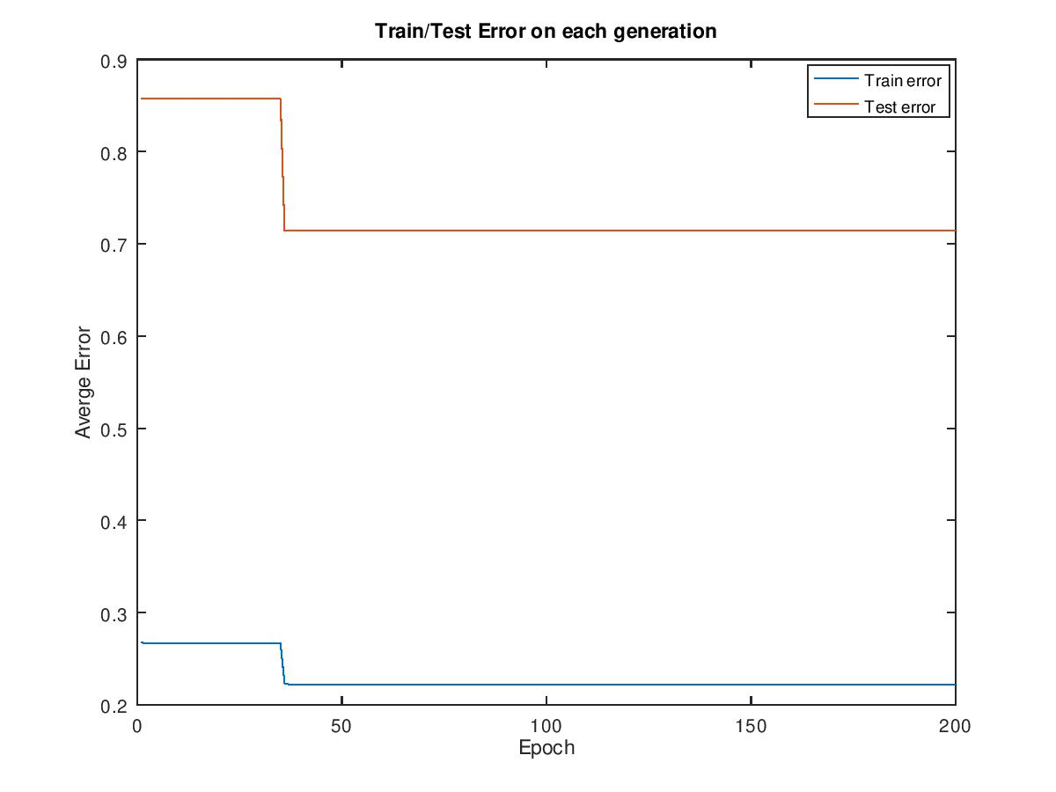

**Minimum MSE at each fold with Average MSE for different ANNs:**

